**Banking System**

**MINI PROJECT REPORT**

Submitted to

**Visvesvaraya Technological University**

**BELAGAVI-590018**

By,

**Akshay Bhandarkar H 4SU19IS004**

**Aishwarya Raghavendra Bhat 4SU19IS003**

**Achala Narayan Bhat 4SU19IS001**

**Adithya A 4SU19IS002**

Under the guidance of

**SHOBHA SHARMA**

Associate Professor

**in partial fulfillment of the requirements for the award of the degree of**

**Bachelor of Engineering**



**SDM INSTITUTE OF TECHNOLOGY**

(Affiliated to Visvesvaraya Technological University, Belagavi)

**UJIRE – 574240**

**Department of Information Science and Engineering**

***CERTIFICATE***

Certified that the project work titled **‘Banking System’** is carried out by **Mr. Akshay Bhandarkar H (4SU19IS004), Miss. Aishwarya Raghavendra Bhat( 4SU19IS003), Miss. Achala Narayan Bhat (4SU19IS001), Mr. Adithya A(4SU19IS002)** are bonafied students of SDM Institute of Technology ,Ujire, in partial fulfillment for the award of the degree of **Bachelor of Engineering** in Information Science and Engineering of Visvesvaraya Technological University, Belagavi during the year 2020-2021.It is certified that all the corrections/suggestions indicated for Internal Assessment have been incorporated in the report deposited in the departmental library. The report has been approved as it satisfies the academic requirements in respect of project work prescribed for the said Degree.

Ms. Shobha Sharma Dr. Dharmanna L Dr. Ashok Kumar T

Asst. Professor and Guide Assoc. Professor and Head Principal

Signature with date and seal:

**Acknowledgement**

We express our deepest gratitude to our guide Ms. Usha G R, Asst. Professor, Department of Information Science and Engineering, for her valuable guidance and encouragement while doing this project work.

We are indebted to Dr. Dharmanna L, Head of the Department and Dr. Ashok Kumar T, Principal,for their advice and suggestions at various stages of the work.

We also extend our thanks to the management of SDM Institute of Technology, Ujire, for providing an excellent study environment, reference materials and laboratories facilities.

We remain grateful to the co-operation and help rendered by the teaching and non-teaching staff of the department.

Akshay Bhandarkar H

Aishwarya Raghavendra Bhat

Achala Narayan Bhat

Adithya A

**ABSTRACT**

Culinary business is a business opportunity that is most in-demand, E Bill Resto is restaurant billing system that was developed by involving several selling places/restaurants with the name of a brand that is connected to the parent company by a database server. With an integrated system, all revenue from restaurant sales can be monitored in real time. The system design is made by implementing the RESTFUL API architecture with security access tokens. The Master Application as a provider of Embedded Data Service Web resources on 3 Restaurant Information Systems, It does the synchronization of 3 Web Services Clients, Data From the Master-Slave Side was obtained by testing 3 data samples, where both applications are tested QOS(Quality of Service) with 3new data samples, from the INDOSAT Internet Provider which showed an average test result of Throughput of 170.3

**INTRODUCTION**

Banks accept deposits and make loans and make profit from the difference in the interest rates paid on deposits and charged for loans. Bank works because of our trust. We give bank our money to keep it safe for us, and then bank lends it to someone else in order to make money for itself. Bank can legally lend far more money than they have cash. Still, most of us have total trust in the banks ability to protect our money and give it to us when we ask for it.

This project consists of deposit, transfer, withdrawal, simple interest, total deposit.

**SYNOPSIS**

1.Title of the project:

Banking system

2.Objective of the project:

The bank has been working for Accounts information, Withdrawal, Deposit amount. In this software you can keep record.

This system facilitates to store the user name, account number, withdrawal money, deposit, simple interest.

3.Module description:

From an end-user perspective, the online banking system project consist of three functional elements: customer transaction module, employee transaction module and manager module.

**CODE**

#include<stdio.h>  
#include<stdlib.h>  
#include<conio.h>

int list();  
void about();  
void deposit();  
void last();  
void transfer();  
void withdraw();  
void si();  
int TotalAmount=1000,Amount,Amo,Tr,Totaldeposit=0,Totalwith=0;  
int TotalTr=0;  
int Acc;  
char name[50];  
float principal_amt, rate, simple_interest;  
    int time;

void main()  
{  
printf("\n Enter your name!");  
scanf("%s",name);  
printf("\n Enter your Acc number!");  
scanf("%d",&Acc);  
while(1)  
{

switch(list())  
{  
case 1:  
deposit();  
Totaldeposit+=Amount;  
break;  
case 2:  
withdraw();  
if(Amo<=TotalAmount)  
Totalwith+=Amo;  
break;  
case 3:  
transfer();  
if(Tr<=TotalAmount)  
TotalTr+=Tr;  
break;  
case 4:  
si();  
break;  
case 5:  
about();  
break;  
case 6:  
last();  
exit(0);  
default:  
printf("\n invalid choice:");  
}  
}  
}  
int list()  
{  
int ch;  
printf("\n1.Deposit Amount:");  
printf("\n2.withdraw Amount:");  
printf("\n3.transfer Amount:");  
printf("\n4.simple interest:");  
printf("\n5.about:");  
printf("\n6.Exit");  
printf("\nEnter your choice:");  
scanf("%d",&ch);  
return(ch);  
}  
void deposit()  
{  
printf("\n Enter the Amount you want to deposit: ");  
scanf("%d",&Amount);  
TotalAmount+=Amount;  
}  
void withdraw()  
{  
printf("\nEnter the amount you wish to withdraw:");  
scanf("%d",&Amo);  
if(Amo<=TotalAmount)  
TotalAmount-=Amo;  
else  
printf("\nless Amount withdraw is not possible:");  
}  
void transfer()  
{  
printf("\n Enter the amount you want to transfer:");  
scanf("%d",&Tr);  
if(Tr<=TotalAmount)  
TotalAmount-=Tr;  
else  
printf("\n less amount transfer is not possible:");  
}  
void si()  
{  
      printf("Enter the values of principal_amt, rate and time \n");  
    scanf("%f %f %d", &principal_amt, &rate, &time);  
    simple_interest = (principal_amt * rate * time) / 100.0;  
    printf("Amount = Rs. %5.2f\n", principal_amt);  
    printf("Rate = Rs. %5.2f\n", rate);  
    printf("Time = %d years\n", time);  
    printf("Simple interest = %5.2f\n", simple_interest);

}  
void last()  
{  
    printf("\n************************************************************");  
    printf("\nYour Name=%s",name);  
     
    printf("\nyour Account number=%d",Acc);  
    printf("\nTotal Amount=%d",TotalAmount);  
    printf("\nTotal Deposited Amount=%d",Totaldeposit);  
    printf("\nTotal Withdrawn Amount=%d",Totalwith);  
    printf("\nTotal Transfered Amount=%d",TotalTr);  
     printf("\nSI=%f",simple_interest);  
     printf("Dear Customer's, Thank you so much for allowing us to help you with your recent account opening. We are committed to providing our customers with the highest level of service and the most innovative banking products possible.");

 printf ("\n\n************************THANK YOU******************************");  
     }  
void about()  
    {  
        printf("\nTHIS IS THE PROJECT CREATED BY 4th SEM ISE STUDENTS OF SDMIT-UJIRE 2021 FOR MINI PROJECT UNDER THE GUIDANCE OF MRS SHOBHA SHARMA THE LIST OF STUDENTS ARE:\nAKSHAY BHANDARKAR H\nADITYA ATIKUKKE\nACHALA\nAISHWARYA " );  
    }

OUTPUT

we are using online compiler for compiling the project code.

STEPS:

1.The compiler will be asking for input your name once you type the text in the window press enter.

2. Submit your account number. 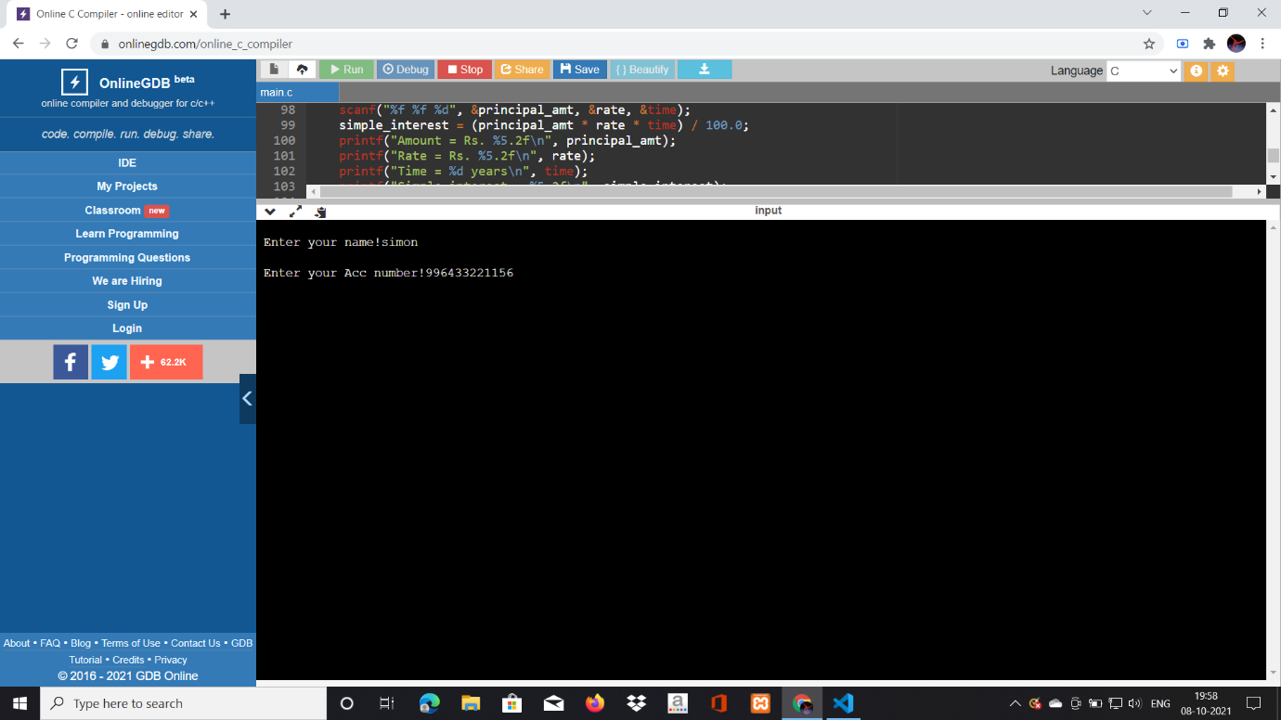

Once we input account number the compiler will be raising question about what will be the next procedure to be done,choose DEPOSIT AMOUNT,WITHDRAW AMOUNT,TRANSFER AMOUNT ,CALCULATE SIMPLE INTEREST.

1.Deposit Amount

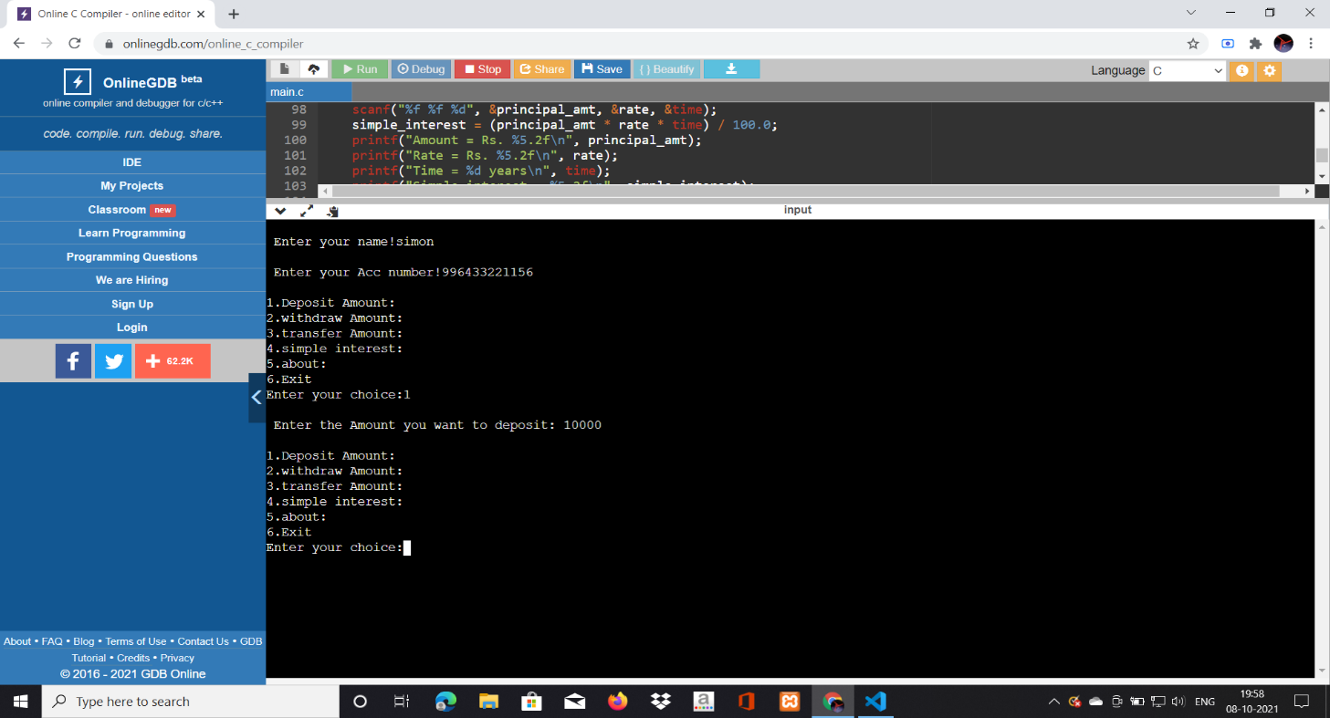

2. Transfer Amount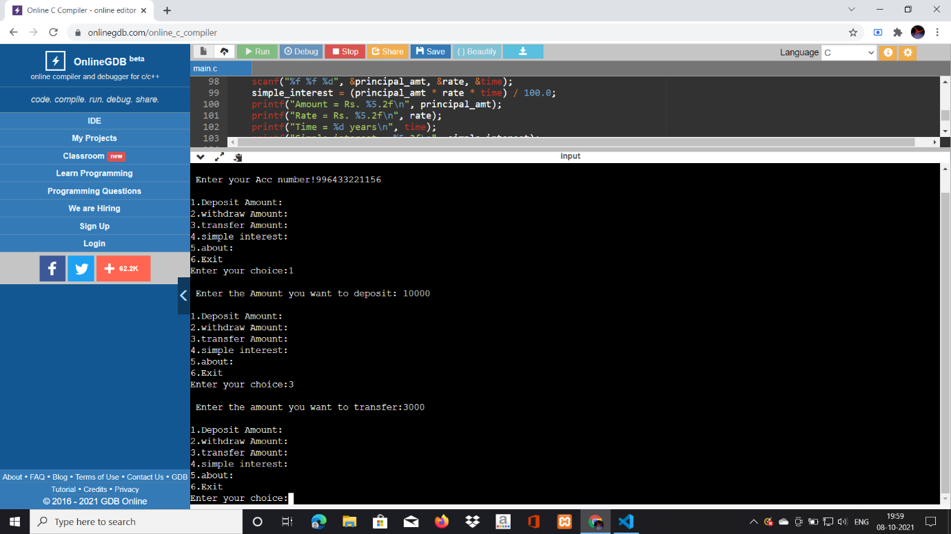

3.Withdraw Amount.

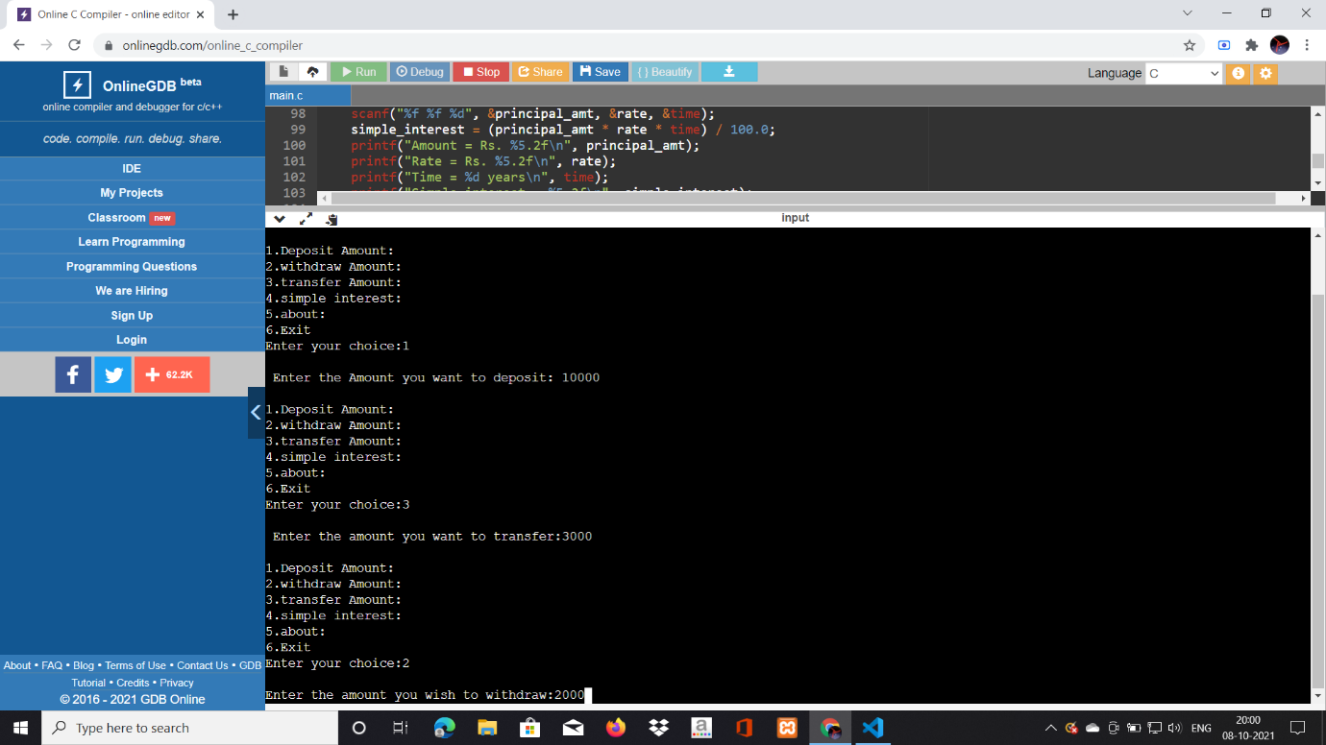

4. Calculate the Simple interest.

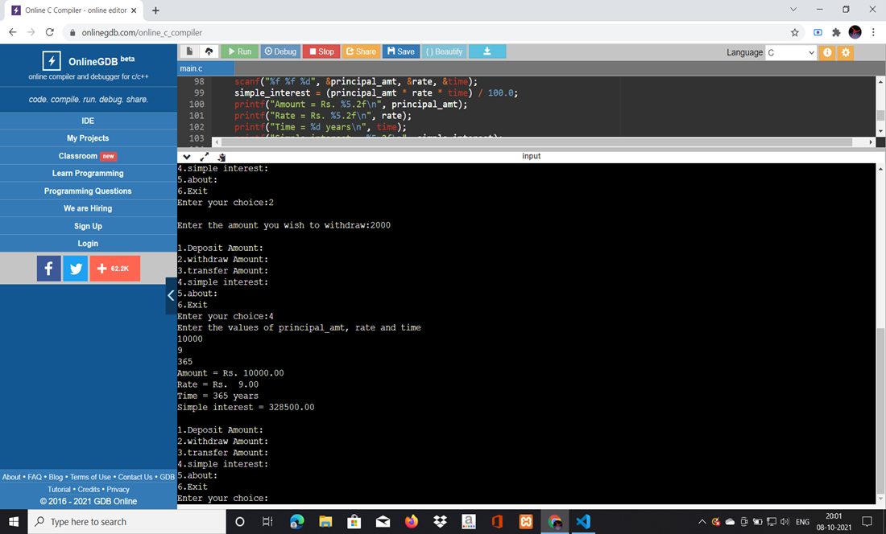

5.FINAL OUTPUT

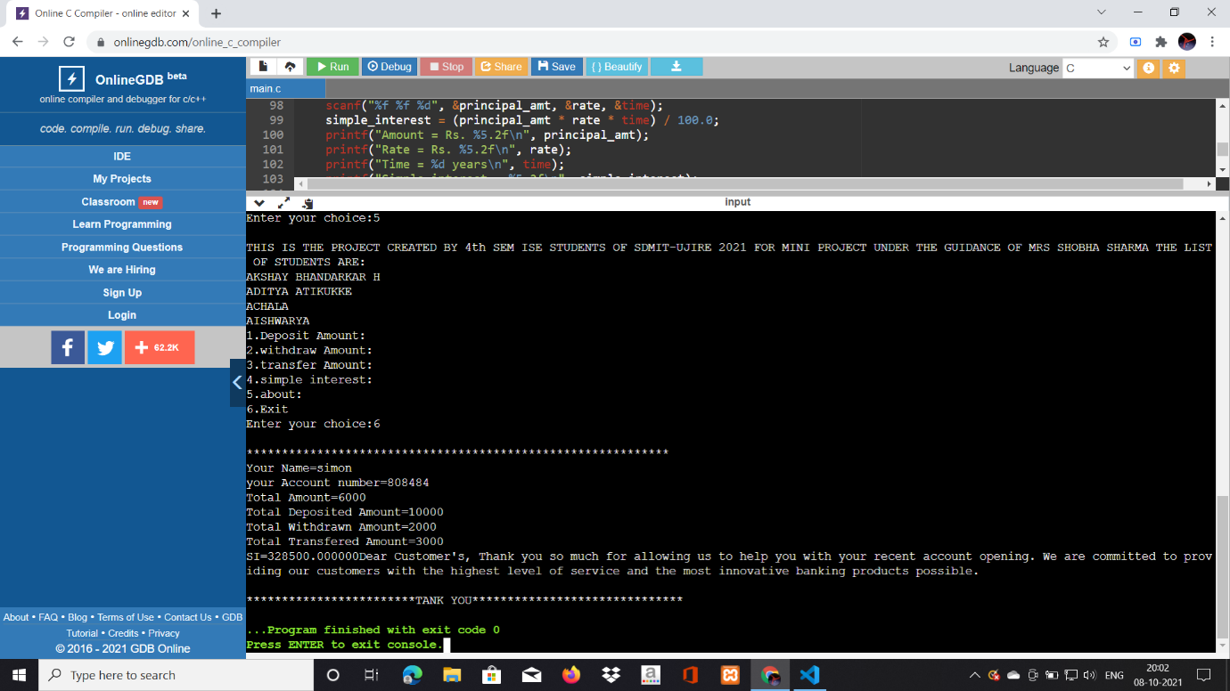

6.About option**.**

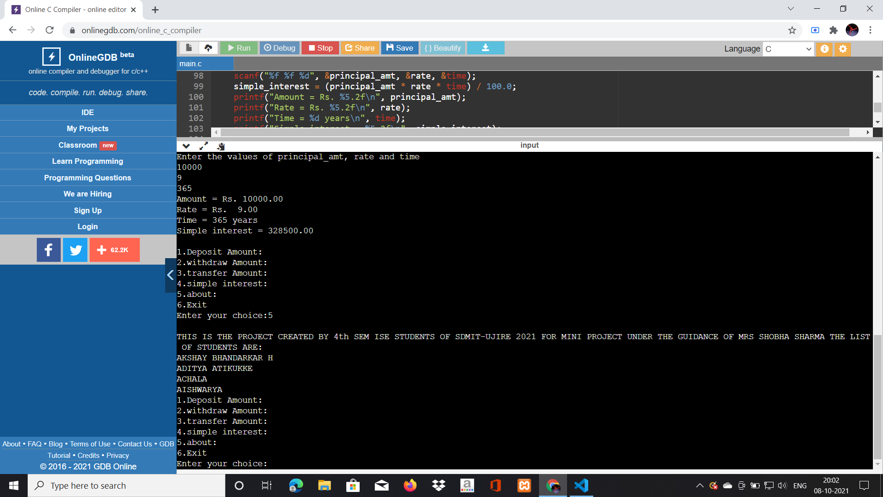

Hence the execution of the of the banking software completed and further we can scope up for its uses and applications.

**CONCLUSION**

Banking system is one which we trust and use at the most in our daily life. It has developed the worldwide transaction a very easy process. The present technology views will be more creative that implements every requirements of an individual along their fingertips.

Banks are a critical intermediary in what is called the payment system, which helps an economy exchange goods and services for money or other financial assets. ... Thus, banks lower transactions costs and act as financial intermediaries they bring savers and borrowers together. We opt every small decisions to be safe and secure and that’s the perspective we have created a small virtue of banking system were we perform all the basic operations takes place in present banking system. This software systems can be implemented among various embedded systems applications such as ATM’s, Internet Banking etc.

We recommend to follow the online banking system as the process of transaction will be safe and secure and within no span of time it could be done. Here this software gives the user what the process has been carried out and what will be his next piece of work has to be completed.